**Harshada Nande**

**Concepts of Operating System**

**Assignment 1**

**Problem 1**

a) Navigate and List:

a. Start by navigating to your home directory and list its contents. Then, move into a

directory named "LinuxAssignment" if it exists; otherwise, create it.

**Ans:**

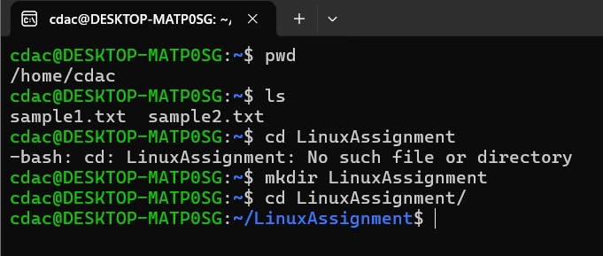

b) File Management:

a. Inside the "LinuxAssignment" directory, create a new file named "file1.txt". Display its contents.

**Ans**

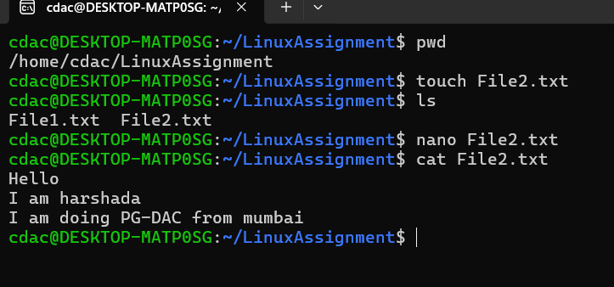

c) Directory Management:

a. Create a new directory named "docs" inside the "LinuxAssignment" directory.

**Ans**

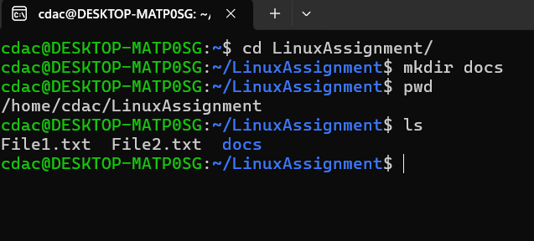

d) Copy and Move Files:

a. Copy the "file1.txt" file into the "docs" directory and rename it to "file2.txt".

**Ans**

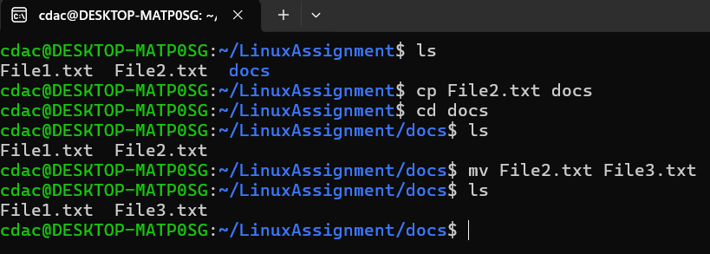

f) Final Checklist:

a. Finally, list the contents of the "LinuxAssignment" directory and the root directory to ensure that all operations were performed correctly.

**Ans:**

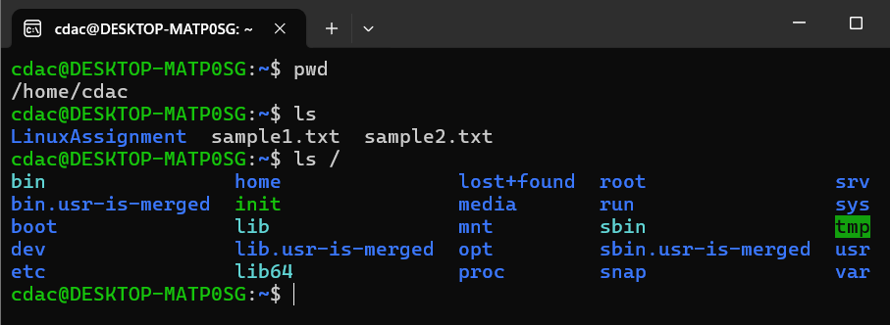

g) File Searching:

a. Search for all files with the extension ".txt" in the current directory and its subdirectories.

**Ans:**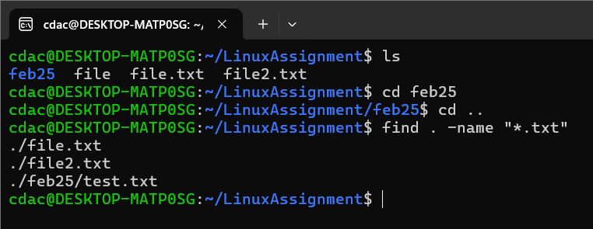

b. Display lines containing a specific word in a file (provide a file name and the specific word to search).

**Ans:**

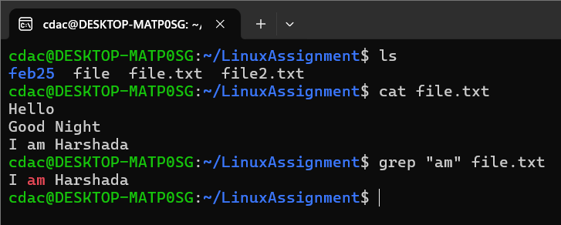

h) System Information:

a. Display the current system date and time.

**Ans:**

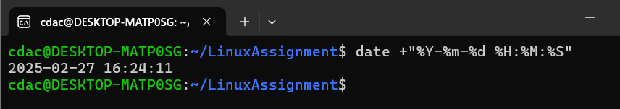

i) Networking:

a. Display the IP address of the system.

**Ans:**

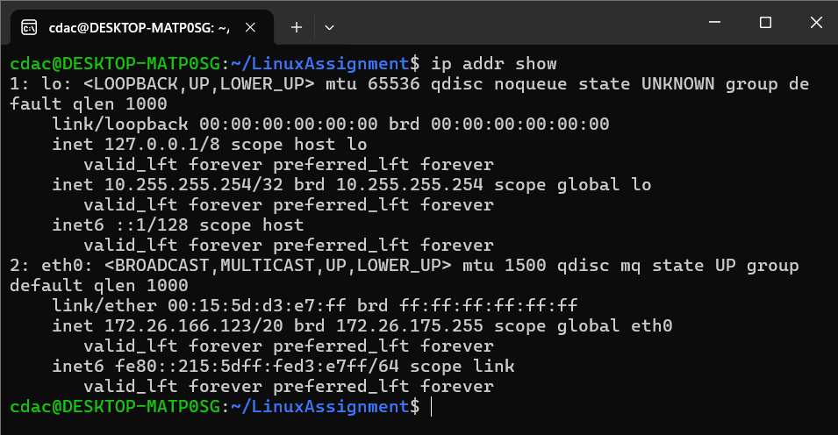

b. Ping a remote server to check connectivity (provide a remote server address to ping).

**Ans:**

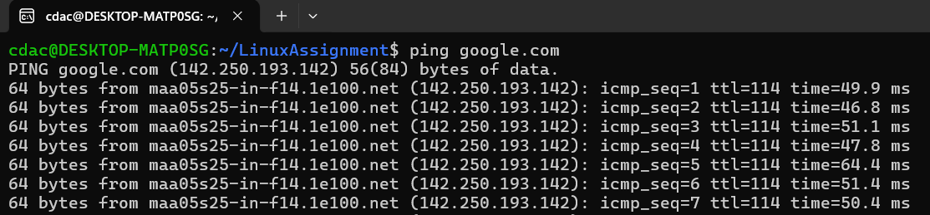

j) File Compression:

a. Compress the "docs" directory into a zip file.

**Ans:**

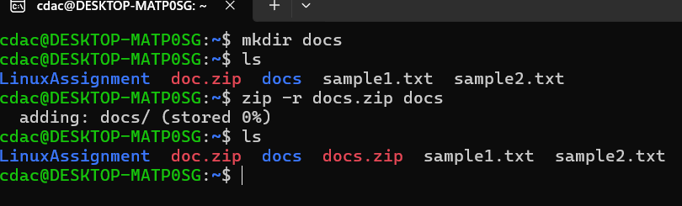

b. Extract the contents of the zip file into a new directory.

**Ans:**

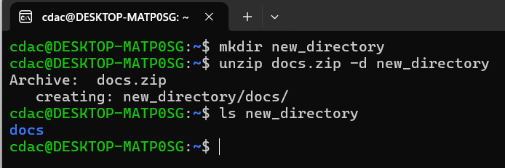

k) File Editing:

a. Open the "file1.txt" file in a text editor and add some text to it.

**Ans:**

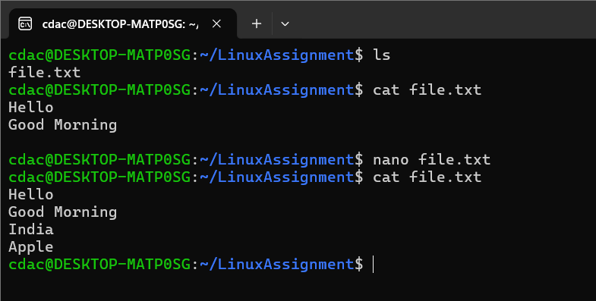

b. Replace a specific word in the "file1.txt" file with another word (provide the original word and the word to replace it with).

**Ans:**

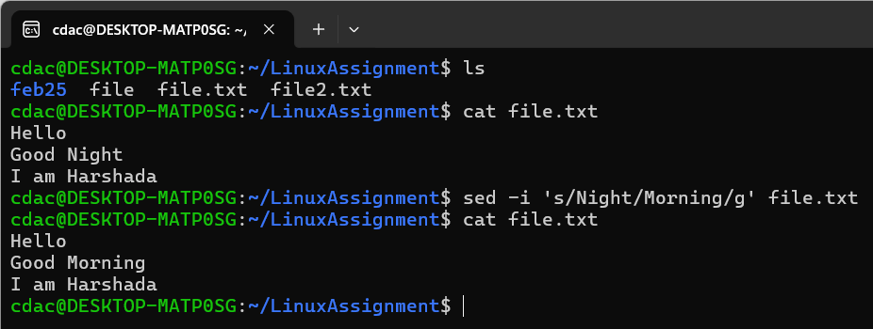

**Problem 2:**

a. Suppose you have a file named "data.txt" containing important information. Display the

first 10 lines of this file to quickly glance at its contents using a command.

**Ans:**

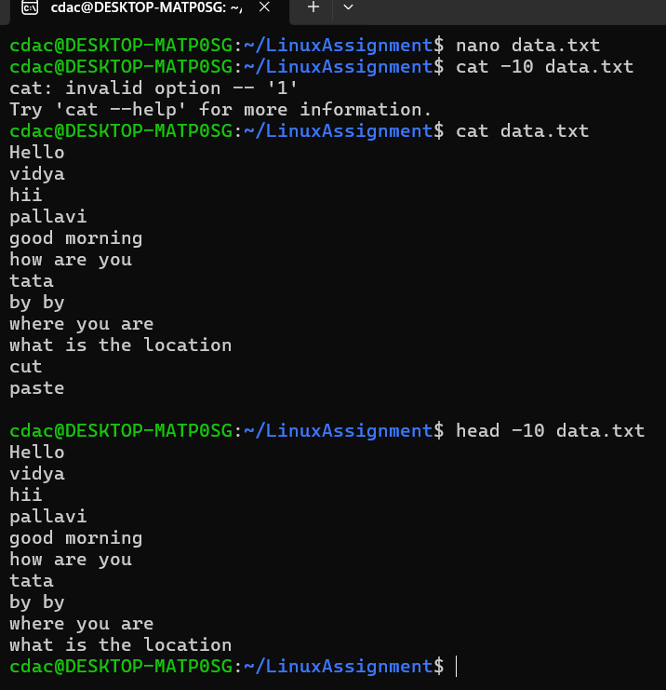

b. Now, to check the end of the file for any recent additions, display the last 5 lines of

"data.txt" using another command.

**Ans:**

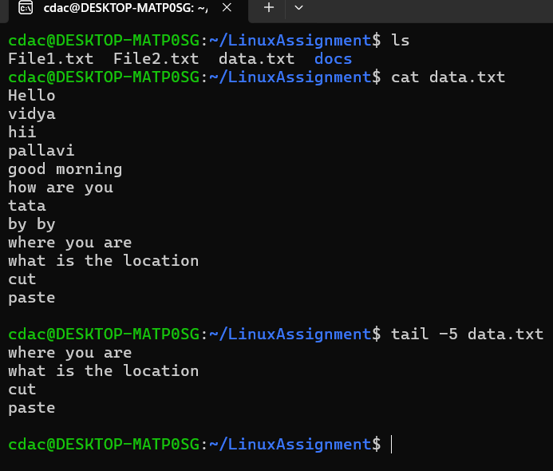

c. In a file named "numbers.txt," there are a series of numbers. Display the first 15 lines of

this file to analyze the initial data set.

**Ans:**

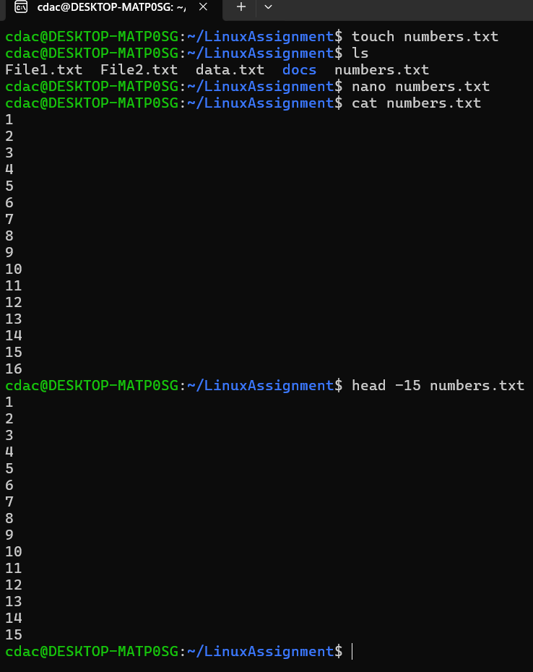

d. To focus on the last few numbers of the dataset, display the last 3 lines of "numbers.txt".

**Ans:**

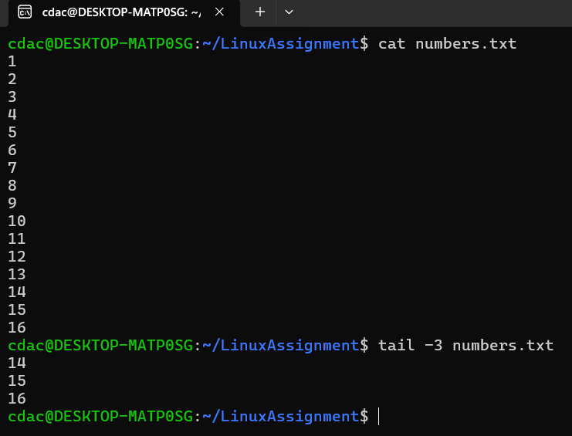

e. Imagine you have a file named "input.txt" with text content. Use a command to translate

all lowercase letters to uppercase in "input.txt" and save the modified text in a new file

named "output.txt."

**Ans:**

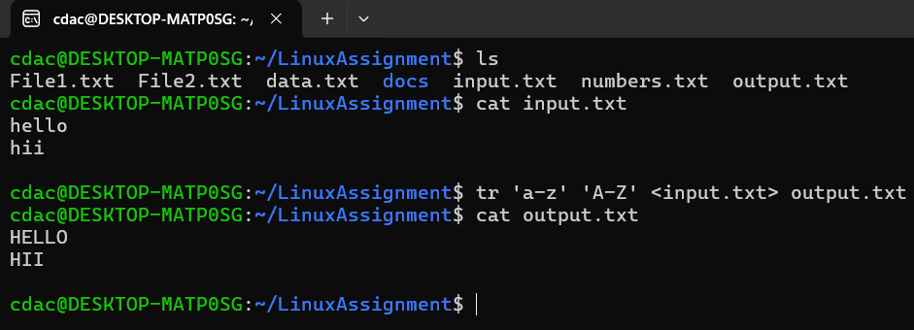

f. In a file named "duplicate.txt," there are several lines of text, some of which are

duplicates. Use a command to display only the unique lines from "duplicate.txt."

**Ans:**

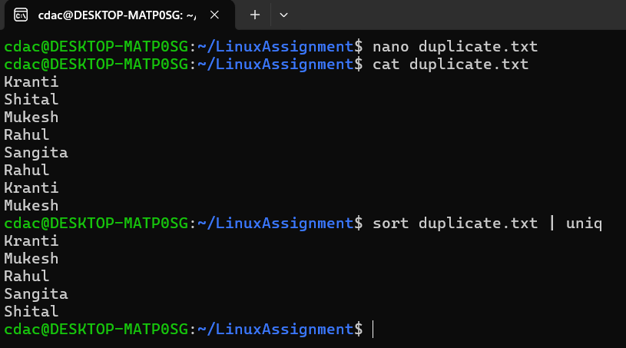

g. In a file named "fruit.txt," there is a list of fruits, but some fruits are repeated. Use a

command to display each unique fruit along with the count of its occurrences in

"fruit.txt."

**Ans:**

